Sinh Viên : Vũ Văn Trọng - 20184206

**ASSIGNMENT 4**

.data

A: .word 7, -2, 5, 1, 5,6,7,3,6,8,5, 6,6,5,4

Aend: .word

.text

main: la $a0,A #$a0 = Address(A[0])

la $a2,A #$a2 = Address(A[i])

addi $a2, $a2, 4 # i = 1

la $a1,Aend

addi $a1,$a1,-4 #$a1 = Address(A[n-1])

addi $s1, $0, 1 # i=1

j sort #sort

after_sort: li $v0, 10 #exit

syscall

end_main:

sort: bgt $a2, $a1, after_sort # for (i = 1; i < n; i++)

lw $t2, 0($a2) # $t2 = arr[i] = key

addi $a3, $a2, -4 # j = i--

while: blt $a3, $a0, skip_while

lw $t3, 0($a3)

ble $t3, $t2, skip_while # while (j >= 0 && arr[j] > key)

addi $t7, $a3, 4 # $t7 = j + 1

sw $t3, 0($t7) # arr[j+1] = arr[j]

addi, $a3, $a3, -4 # j--

j while

skip_while:

addi $a3, $a3, 4 # j++

sw, $t2, 0($a3) # arr[j] = key

addi $a2, $a2, 4

j sort

* **Bảng text segment**

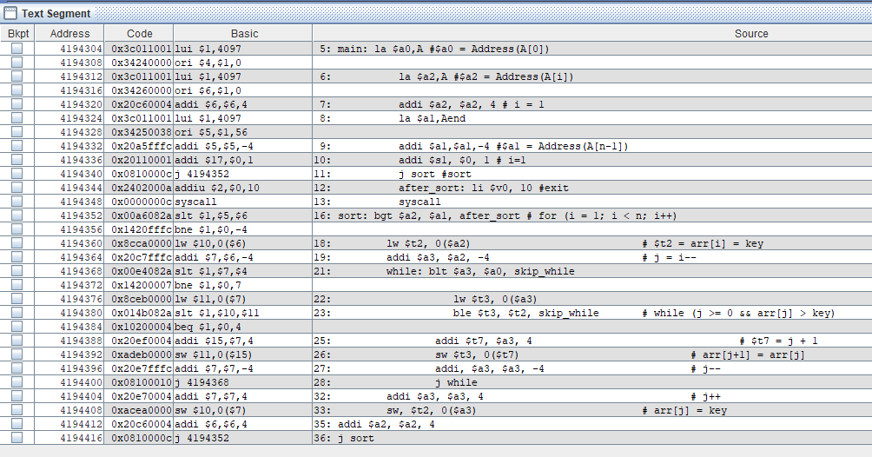

* **Bảng data segment**

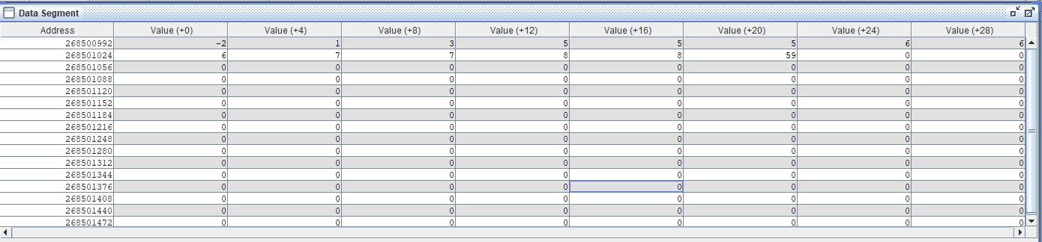

* **Bảng giá trị thanh ghi**

